 | 12.1.35 Editors - Geometry Nodes Editor - Header - Add Menu - Mesh - Normals
Table of content
Detailed table of content 1
Add menu - Mesh - Normals 1
Smooth by Angle 2

Detailed table of content
Detailed table of content
Detailed table of content 1
Add menu - Mesh - Normals 1
Smooth by Angle 2
Inputs 2
Mesh 2
Angle 2
Outputs 2
Mesh 2

Add menu - Mesh - Normals
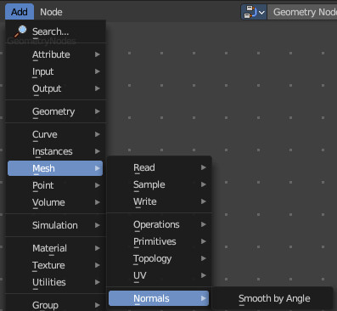
Here you find nodes to modify the UV mapping.
This is a Node Groups found in the Essentials Library included with Bforartists. Node groups differ from the other nodes in the add menu due to being mid level node groups instead of individual low level nodes.
Node groups are not available in the sidebar.

You can enter the node tree by clicking at the icon up right. Tab to leave the node tree. And you can of course also edit the node tree.




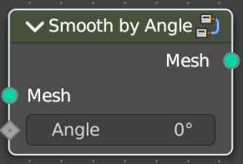
Smooth by Angle
Pack the UV islands to get the most out of the UV mapping.

Inputs

Mesh
The input geometry.

Angle
Everything higher than this angle will be smoothed.

Outputs

Mesh
The output geometry.

